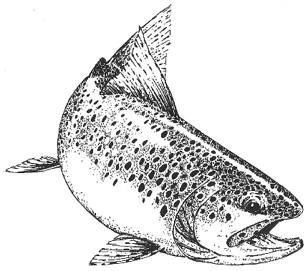
Wild Trout Association
Member’s Newsletter
October 2026

First and foremost, on behalf of the Wild Trout Association, I would like to convey our sincere condolences to all of the family members at the passing of Chrissie Barnard and Tauber van Zyl. Their unflagging support down the years has been highly valued and very much appreciated by both the WTA and fly fishers.
In addition to the following items that have had limited circulation, I am delighted to announce that the WTA website has been thoroughly overhauled and updated. It can be viewed using the URL; https://wildtrout.co.za It is based on the WTA guidebook so now we have both digital and hard copy editions of the most comprehensive assemblage of information on fly fishing in the Eastern Cape Highlands. It is a veritable tome of 249 pages.
It would be appreciated if you would peruse the site and let me know if you would like to suggest any changes to be made, especially to the directions to beats as well as accommodation descriptions. It is our task to provide the most accurate information that we have at our disposal to visiting fly fishers to augment their enjoyment of the resource.
I would also like to convey our thanks to Heather Ralph for putting her shoulder to the wheel concerning pointing the website editor in the right direction!
WTA PROJECTS’ and activity’s update, once-off and ongoing
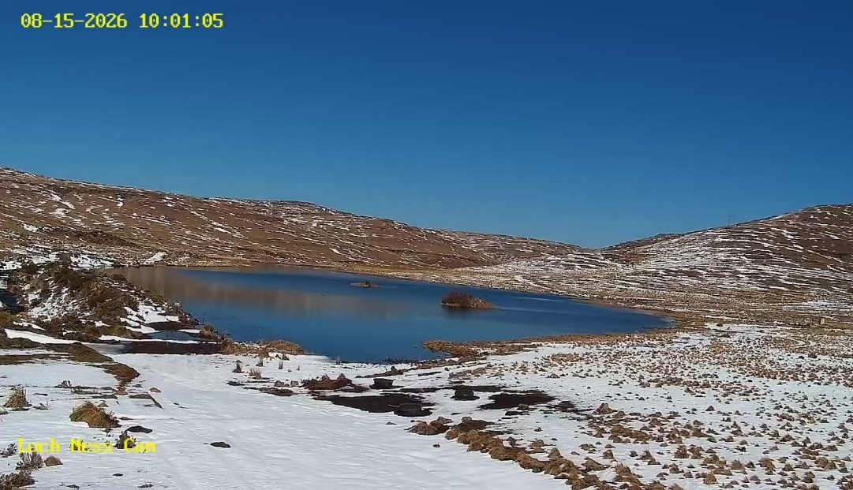
One of the WTA cameras at Loch Ness continued to provide images of passing vehicles and their number plates until it got a hiccup, but which will be rectified in the near future. The second camera’s 360-degree coverage & zoom capability allows the operator to see activities in great detail including a view of the ski lift to the top of Ben Mac or veld fires in the surrounding area, as well as of both permitted fly fishers & illegal poachers at Loch Ness!
As can be expected, day permit sales were adversely affected by the onslaught of the Foot and Mouth Disease epidemic, i.e. zero sales in February 2026. However, very many thanks to riparian members who agreed to allow flyfishers onto their properties subject to them abiding by the appropriate protocols in this regard that allowed the 2026 Dirt Road Wild Trout Festival to proceed.
2026 festival was yet another successful event & in particular, our thanks to Ronnie Small who made his “Firefighter” unit available for spraying participants vehicles before heading out to the beats allocated. The event’s auction continues to generate revenue for the association’s charitable function as well as for the Rhodes Animal Care project in the form of Rhodes Stoepsitfees blanket sales.
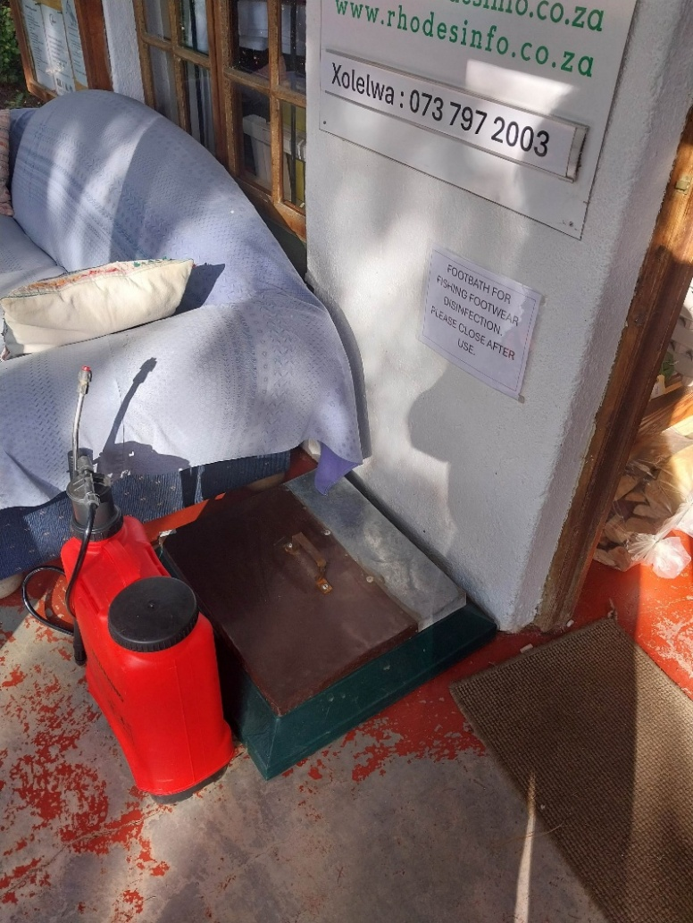
The knapsack spraying units and the footbaths at Walkerbouts and the Rhodes Info Centre continue to allow anglers to comply with the F&M D fishing protocols set in place before the 2026 festival. The red unit with disinfectant was kindly donated by a regular festival participant, Anthony Stein.

For clarity on day permit fees, the amount charged is R175/rod/day. Of this R20 accrues to the Rhodes Info Centre (RIC) where the permits are issued. R30 is retained for WTA administrative and marketing purposes while R125 accrues to the Riparian member. The day permit fee paid to the RIC is a much-needed contribution to the entity that goes toward ensuring that it continues to operate as a largely self-funding community service.
The RIC only receives occasional support from the Senqu Municipality tourism budget. An amount of R5000 was contributed by the WTA for veterinary disinfectant for use at the Matla FMD disinfection station in Ekephini (Barkly East).
Three vehicles and manual labour was provided for 2 days’ work on the road to Tiffindell in the Carlisleshoek valley and at the top of the pass resulted in the worst of the eroded gullies being filled with stones and some gravel. The previous year, a TLB was hired and that could and did much more work on the road than was possible by hand!
The Day Permit sales point at the Rhodes Info Centre continues to provide a fine service for visiting flyfishers. This service together with that of the WTA administration, treasurer & auditor provide a seamless service for collecting and distributing day permit fees. Many thanks to the RIC staff and especially the “de-Sasol-ed” members of the WTA team!
2027 festival is just around the corner. A few years ago, it almost seemed like an old-boys club, however, it is pleasing to note the number of first-time participants who form part of the field, amounting to almost 30% of the field. This is wholly in line with the WTA policy since inception regarding attracting new visitors to the Highlands.
At the risk of being repetitive, this ripple effect is part and parcel of having an annual festival, the purpose of which is mainly to attract and introduce new visitors to the area while providing an opportunity to regular festival-goers to return and renew fishing friendships developed down the years. An appropriate analogy is a pebble thrown into a pool. The pebble’s “ripple effect” has held true ever since the WTA was established in 1991.
In closing, our sincere thanks again to all of our riparian members. Without you, there would be no WTA and without some form of administering access to water, there would be chaos including more poachers from the bright lights and/or of local origin.

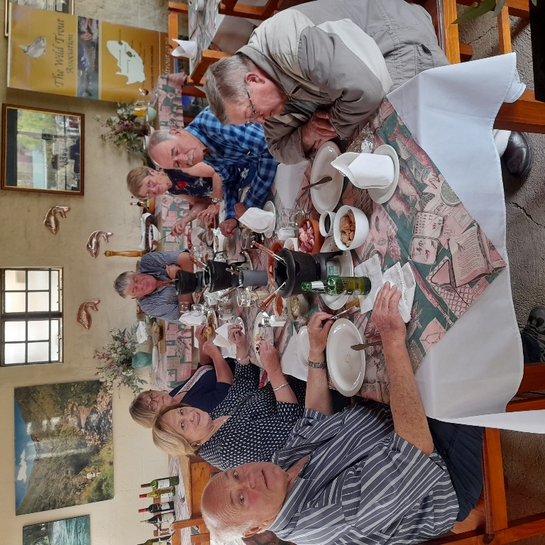
Member’s luncheon participants down the years
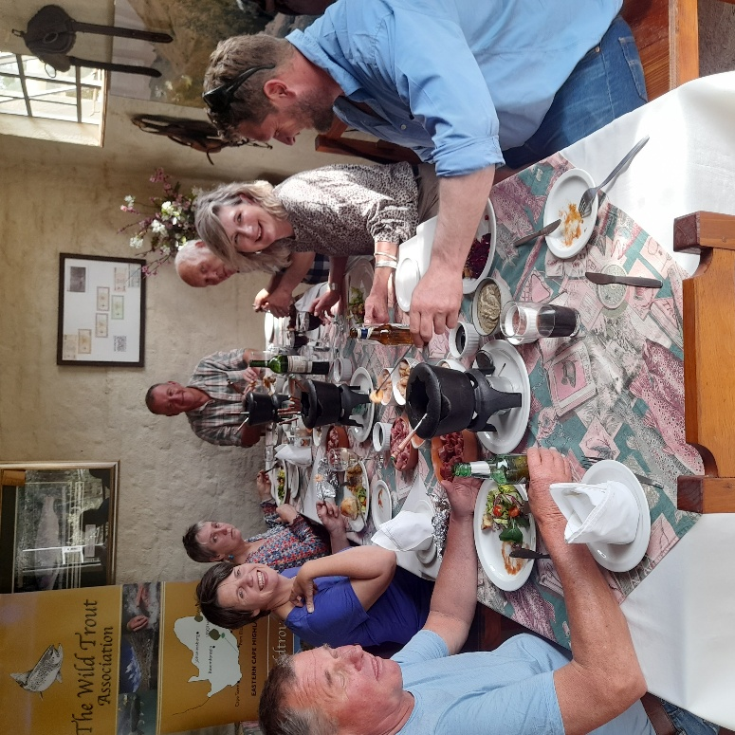
Clockwise: Ronnie Small, Tinnie Small, Susan Naude, Loekie Smith, Rassie Smith, Chrissie Barnard

Clockwise: Rudi Hiestermann, Heather Ralph, Sharlene Sankey, Janbert Reeders, Vaasie Murray, Carien Vosloo, Arnie Vosloo.

Graph 1

Graph 2

The impact of high and low (La Niňa & El Niňo) precipitation as well as the Covid epidemic are clearly reflected in Graph 2

